**Jenkins Setup On EC2 Ubuntu Machine**

**Provision EC2 Ubuntu VM**

**Open ports**

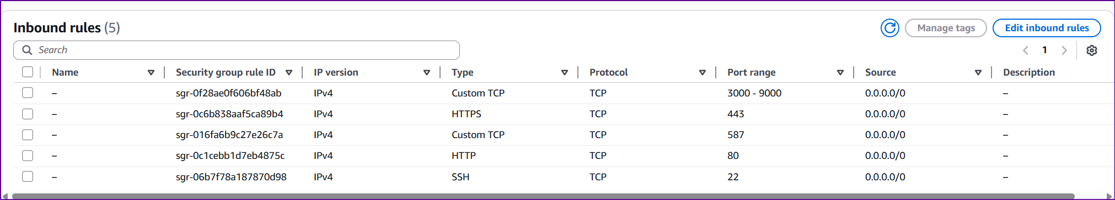

**Install Java**

sudo apt install openjdk-21-jre-headless -y

**Install Jenkins**

sudo wget -O /etc/apt/keyrings/jenkins-keyring.asc \

https://pkg.jenkins.io/debian-stable/jenkins.io-2023.key

echo "deb [signed-by=/etc/apt/keyrings/jenkins-keyring.asc]" \

https://pkg.jenkins.io/debian-stable binary/ | sudo tee \

/etc/apt/sources.list.d/jenkins.list > /dev/null

sudo apt-get update

sudo apt-get install Jenkins -y

sudo systemctl enable Jenkins

**Install gitleaks**

sudo apt install gitleaks

**Install Trivy**

sudo apt-get install wget apt-transport-https gnupg lsb-release

wget -qO - https://aquasecurity.github.io/trivy-repo/deb/public.key | sudo apt-key add -

echo deb https://aquasecurity.github.io/trivy-repo/deb $(lsb_release -sc) main | sudo tee -a /etc/apt/sources.list.d/trivy.list

sudo apt-get update

sudo apt-get install trivy

**Install Docker**

# Add Docker's official GPG key:

sudo apt-get update

sudo apt-get install ca-certificates curl

sudo install -m 0755 -d /etc/apt/keyrings

sudo curl -fsSL https://download.docker.com/linux/ubuntu/gpg -o /etc/apt/keyrings/docker.asc

sudo chmod a+r /etc/apt/keyrings/docker.asc

# Add the repository to Apt sources:

echo \

"deb [arch=$(dpkg --print-architecture) signed-by=/etc/apt/keyrings/docker.asc] https://download.docker.com/linux/ubuntu \

$(. /etc/os-release && echo "${UBUNTU_CODENAME:-$VERSION_CODENAME}") stable" | \

sudo tee /etc/apt/sources.list.d/docker.list > /dev/null

sudo apt-get update

sudo apt-get install docker-ce docker-ce-cli containerd.io docker-buildx-plugin docker-compose-plugin

**Add Jenkins user to docker group**

sudo usermod -aG docker jenkins

**Install DotNET 8**

# 1. Install Microsoft package repo

wget https://packages.microsoft.com/config/ubuntu/$(lsb_release -rs)/packages-microsoft-prod.deb -O packages-microsoft-prod.deb

sudo dpkg -i packages-microsoft-prod.deb

rm packages-microsoft-prod.deb

# 2. Install required dependencies

sudo apt-get update

sudo apt-get install -y apt-transport-https

# 3. Install .NET 8 SDK

sudo apt-get update

sudo apt-get install -y dotnet-sdk-8.0